# C:\Users\Messom\Desktop\Monash.jpg

# FIT5032 Design Report (Credit/Distinction/High Distinction Code Task)

# Safe Point

Richard Aldrich Siem:25246860

**Contents Page**

**Your design report must include the following:**

**Credit Level**

1. Overview of your application's goals
2. User stories
3. Functional diagram
4. Usability Design Review
5. Checklist of site functionality.

**Additional Distinction Level (the above and the following)**

1. Your selected approach when constructing the application
2. Class Diagram or Entity Relation Diagram
3. Data dictionary

**Additional Distinction Level (the above and the following)**

1. Development Methodology
2. Versioning
3. **Overview**

The system will have two main modules. A reservation module and a map module. These two modules will support the main objectives of this application which is helping people to look for hospital(s) with or without GPS Location Services and make a reservation on that hospital.

1. **User stories**

As a user, I want to be able to easily search for a hospital near me and make a reservation in the same website, so that I can use my time more efficiently.

1. **Functional diagram**

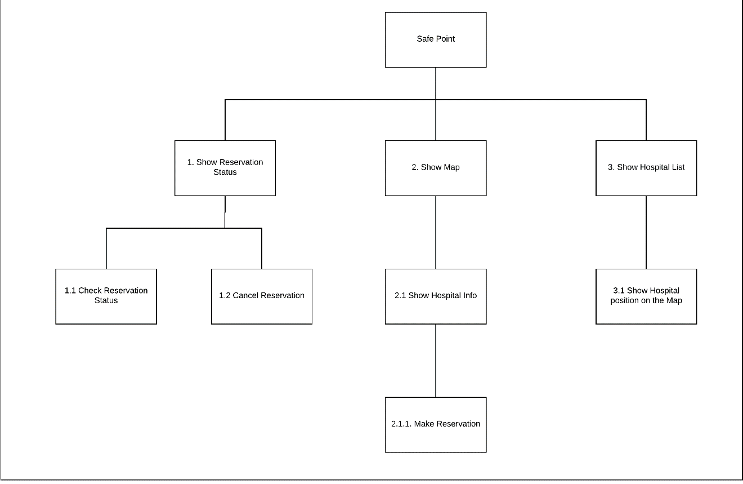

1. **Usability Design Review**

This application will be using Donald Norman Principles of Design which consists of visibility, feedback, constraints, mapping, consistency and affordance.

1. **Checklist of site functionality**

|  |  |
| --- | --- |
| **1. (Layout Page)** | **TICK**  **if complete** |
| Good Design |  |
| Stylesheet |  |
| JavaScript |  |
| Menu |  |
|  |  |
| **2. (Home page)** |  |
| Design and content |  |
| Banner Image |  |
|  |  |
| **3. (User Log in)** |  |
| Web form and validation controls |  |
| Formatted data entry display |  |
| Overall page design |  |
|  |  |
| **4. (Customised Views and Controllers)** |  |
| Customised Views |  |
| Customised Controllers |  |
| Other customisations |  |
|  |  |
| **5. (Documentation)** |  |
| Code Comments |  |
| Attribution of Source of any code used |  |
| **6 Additional Distinction Items** |  |
| **Basic Module 1:** |  |
| Map Module |  |
|  |  |
|  |  |
| **Basic Module 2:** |  |
| Reservation Module |  |
|  |  |
|  |  |
| **7 Additional High Distinction Items** |  |
| **Advanced Module:** |  |
|  |  |
|  |  |
|  |  |
|  |  |
|  |  |
|  |  |
|  |  |
| **Audit** |  |
| No breaking of copyright |  |

**Additional Distinction Level (the above and the following)**

1. **Your selected approach when constructing the application.** (Model First, Code First or Database First)
2. **Class Diagram or Entity Relation Diagram** (If you are using the Model First or Code First approach, you will need to provide a class diagram. An Entity Relationship Diagram (ERD using Crows Feet or Chen Notation) should be provided if you decide to use the Database First methodology.)
3. Data dictionary (This includes the justification of the data types which you use)

**Additional Distinction Level (the above and the following)**

1. **Development Methodology** (A description of your development methodology for this portfolio submission. (For example, did you approach the portfolio submission using a Code and Fix method or using a Test Driven Development). Most students are expected to use the Code & Fix model. (This is completely normal for all assignments))
2. **Versioning** (Description of how you handled the versioning of your project. For example, if you have used [Git](https://www.atlassian.com/git/tutorials/what-is-git), [Mercurial](https://www.mercurial-scm.org/), [CVS](https://en.wikipedia.org/wiki/Concurrent_Versions_System), or [SVN](https://subversion.apache.org/). Please provide evidence of your repository if you have done so. (If you did not use it, justify why). It is not a requirement to use these tools but if you have done so, please state it.)